PHASE 1:
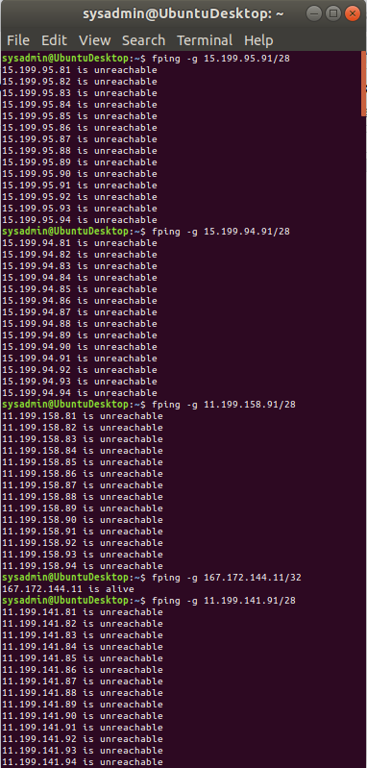
PHASE 1 SUMMARY:
Provided the list of 5 Hollywood IP address I ran the fping -g command against each to determine whether any machine on the suspect subnets would respond. Four of them didn’t, however 167.162.144.11/32 returned output indicating that it was alive. As this machine/subnet responded it is vulnerable. In order to mitigate this vulnerability further research is required, however closing the port would immediately remedy the issue.
Fping is a Layer 3 command.

PHASE 2:
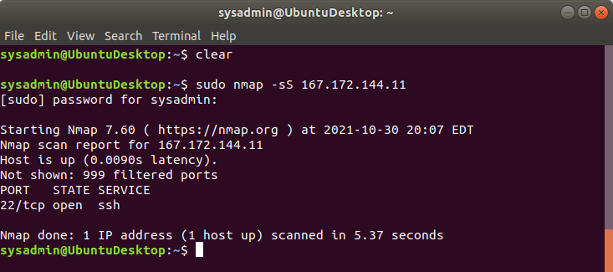
PHASE 2 SUMMARY:
With Nmap using the option -sS for non-invasive connectionless SYN scan, port 22 (ssh) was found open on this IP Address. The scan took place on layer 4. As the vulnerable port was used by the hacker, the threat would be mitigated by closing said port. This is a layer 4 (transport) function. It transmits tcp data.

PHASE 3:
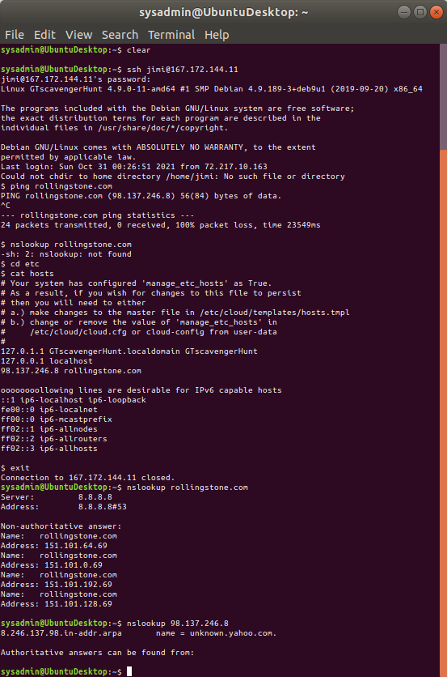

PHASE 3 SUMMARY:
After gaining access to the Hollywood server using Jimi Hendrix credentials I employed ping and nslookup on rollingstone.com. Neither worked. I navigated to /etc and looked at the hosts file with the cat hosts command.
In the hosts file I found this entry: 98.137.246.8 rollingstone.com. This entry is what was causing the company trouble.
Using exit to close the tunnel I ran an nslookup on rollingstone.com from my machine and found different and functional IP addresses for rollingstone.com. I also ran an nslookup on the address found in the hosts file on the hollywood server linked to rollingstone.com. Just for fun i also searched it on the site https://www.findip-address.com/ and came up with a huge amount of information, but was advised to keep this submission short and sweet. anyhow, that particular IP address resolves to unknown.yahoo.com.
These functions occurred on Layer 7 (DNS runs on application layer).
In order to mitigate the issue on this machine the RollingStone.com record should be removed from the hosts config file. Another mitigation would be to blacklist the hacker’s redirection in the /etc/hosts file.

Phase 4:
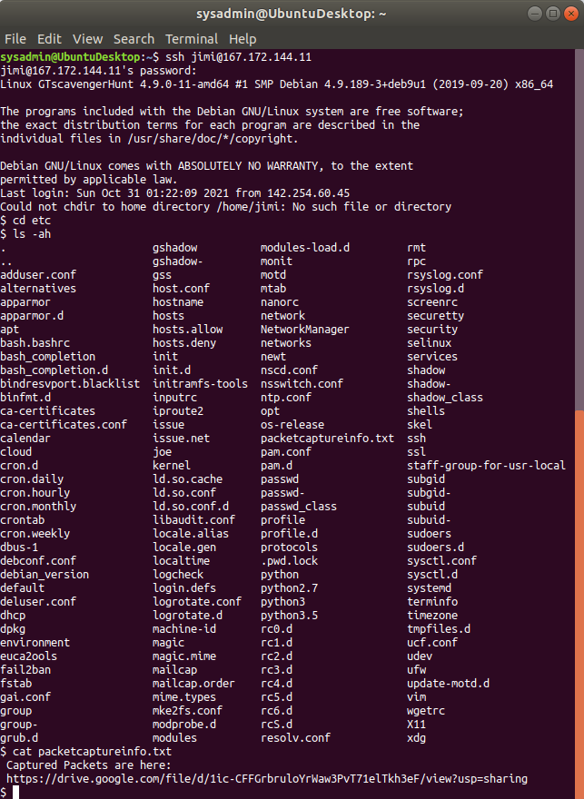

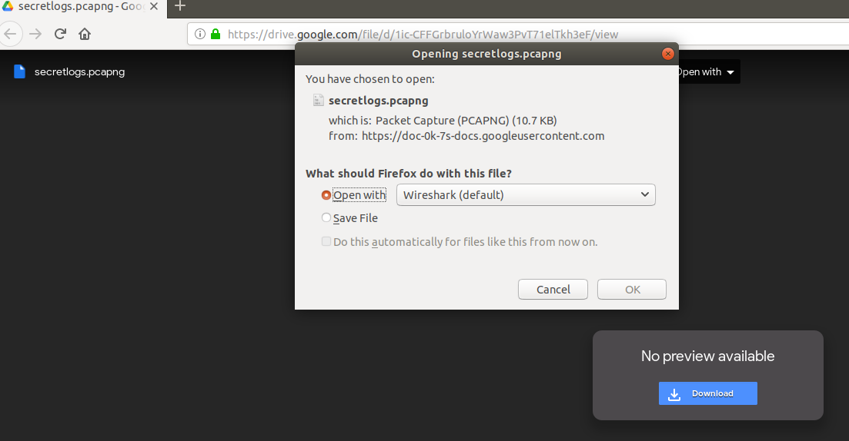
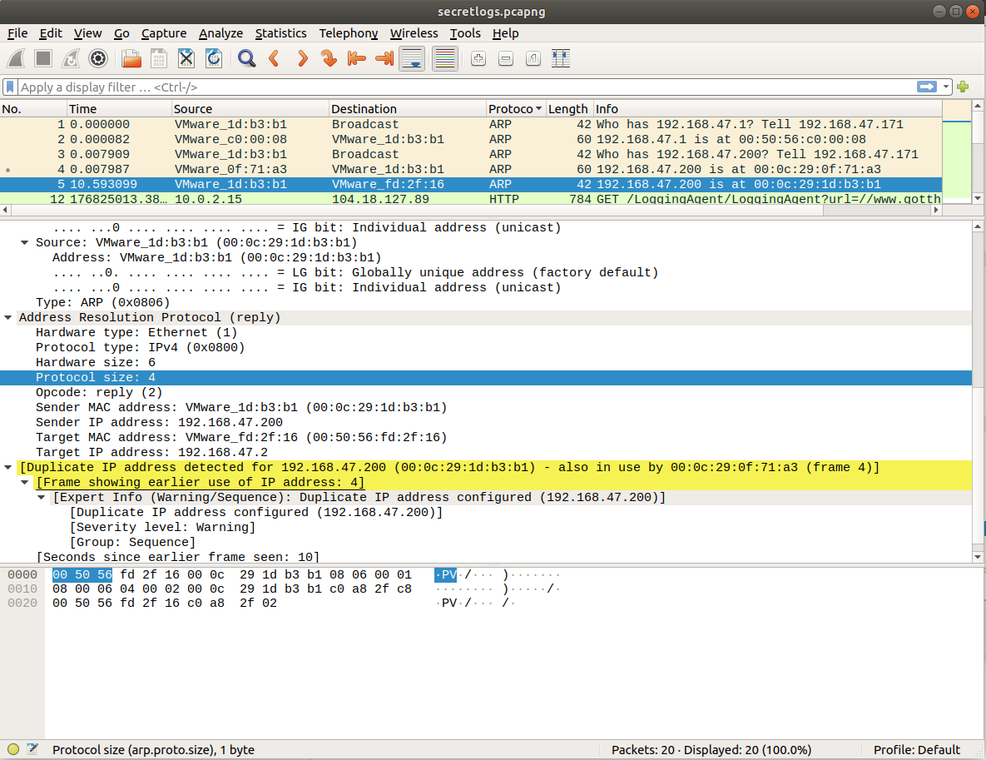

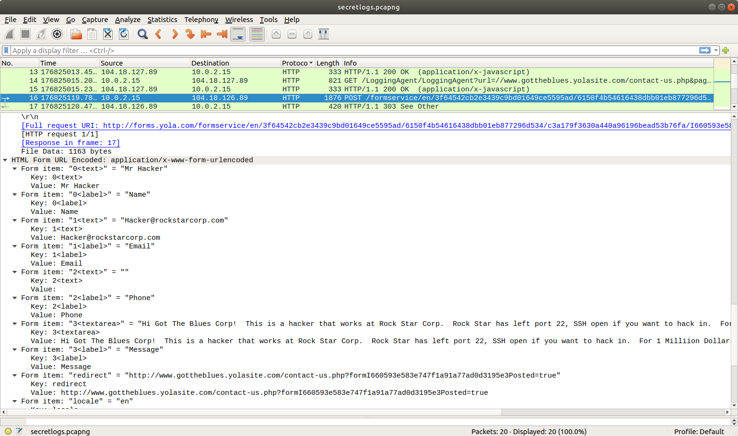

PHASE 4 SUMMARY:
Tunneling into the machine using the Jimi Hendrix creds I navigated to etc with cd, then ran cat packetcaptureinfo.txt, which provided a google drive link. The link lead to packet captures, which i opened with WireShark. Included are screenshots of some of the moret relevant packets. One ARP packet in which an employee attempted to mask their activity by duplicating a preexisting assigned IP address. The following several packets show the employee logging into a different company’s website with the user name Mr. Hacker, and offering them information about the vulnerability for a million bucks. This took place on layer 2 (data link) as that is where Arp requests function. It could be that it is layer2/3 as it resolves an ip address from a MAC address. The company should track the employee down, fire them, turn them into the police (report them, not magically make them into a police), and sue the other company.

